David Tollner MLA and the Gwalwa Daraniki Association Inc – a conflict of interest?
A case study by Dr Bill Day
June 2016
On 29 April 2016, Northern Territory Lands and Planning minister, David (“Dave”) Tollner notified the more than 200 people who made a submission in response to the proposed heritage listing of the 301 hectare Kulaluk Lease Area in suburban Darwin. Ignoring a positive report by Dr David Ritchie and the recommendations of the NT Heritage Council, Tollner wrote that “pursuant to section 35(1) of the Heritage Act, I have decided not to permanently declare the Kulaluk Lease area as a heritage place” (Davidson 2016a, 2015b).
In his correspondence, Tollner (2016) added:
As an affected person within the meaning of the section 93(2) of the Heritage Act, you may appeal against my decision to the Supreme Court on a question of law only. Under Order 83 of the Supreme Court Rules, you must commence any appeal from my decision within 28 days after the date on which this notice is given to you. An appeal is started by filing a notice of appeal in the Supreme Court in accordance with applicable rule of court.

Not surprisingly, an appeal was lodged by the Environment Defenders Office in Darwin acting for the Larrakia Nation Aboriginal Corporation who had nominated the Kulaluk Lease Area as a heritage place in June 2014 (Walsh 2016; Dunlop 2016a, 2016b; Wood 2014:10).

One suggested ground for appeal was David Tollner's clear conflict of interest as the Minister for Lands and Planning and his working relationship with the contested lease-holding Gwalwa Daraniki Association (GDA), who oppose the heritage nomination (Secretary 2016:12). At a public meeting to discuss proposed rezoning of the land, Tollner unashamedly proclaimed he has “a real soft spot for the Gwalwa Daraniki” https://www.youtube.com/watch?v=JhvZIs9TdQw . In addition, as a federal member of parliament Tollner was also closely identified with a disastrous multi-million dollar aquaculture project sponsored by the federal government on the lease area. Furthermore, as Minister for Lands and Planning in the NT government and member for Fong Lim, representing the adjoining suburb of Ludmilla, Tollner has admitted that a contaminated construction stockpile on the lease is “unlawful”, but no action has been forthcoming.

More blatantly, in September 2015, Tollner signed a “Memorandum of Understanding” (MoU) with the Gwalwa Daraniki Association Inc. According to the government media release (Giles & Tollner 2015) Mr Tollner said. “I’m sure the Gwalwa Daraniki Association will succeed and inspire other communities to seize the opportunities offered by the Territory Government.”

Due to this perceived conflict of interest, some observers maintain that Tollner has breached “Improper advantage” as defined by Section 8.8 of the NT Cabinet Handbook which states:

Ministers are not to use their position improperly to gain a direct or indirect personal advantage for themselves, or any other person or entity, not enjoyed by the general public. Ministers are not to use information obtained in the course of their official duties so as to gain a direct or indirect personal advantage for themselves or improperly for any other person or entity not enjoyed by the general public.

The following sections of this case study describe these perceived conflicts of interest in more detail.

The Memorandum of Understanding
On 18 September 2015 a media release by Adam Giles, Chief Minister of the Northern Territory, and David Tollner, Minister for Lands and Planning. was headed, “Indigenous communities free to build a better future” (Giles & Tollner 2015). The media release described a “landmark agreement with the Northern Territory Government” and the Kulaluk leaseholders, the Gwalwa Daraniki Association (GDA). The statement was accompanied by a photograph of a grinning Giles and Tollner with Helen Secretary and members of the GDA signing the Memorandum of Understanding. No further details of the MoU were released.

The NT Government media release continued: “Chief Minister Adam Giles said the Territory Government would work with the GDA to develop an economic master plan for 3sq km of Crown land between Ludmilla Creek and Nightcliff. Lands and Planning Minister David Tollner said he hoped other communities would follow the lead set by the GDA. It’s time we allowed Territorians to take responsibility for their own futures,” Mr Tollner said.

Tollner added: “I’m sure the Gwalwa Daraniki Association will succeed and inspire other communities to seize the opportunities offered by the Territory Government” (see also “Community land to be freehold”, NT News, Friday September 20, 2015.
Below: David Tollner and Adam Giles sign a MoU with members of the GDA in September 2015.
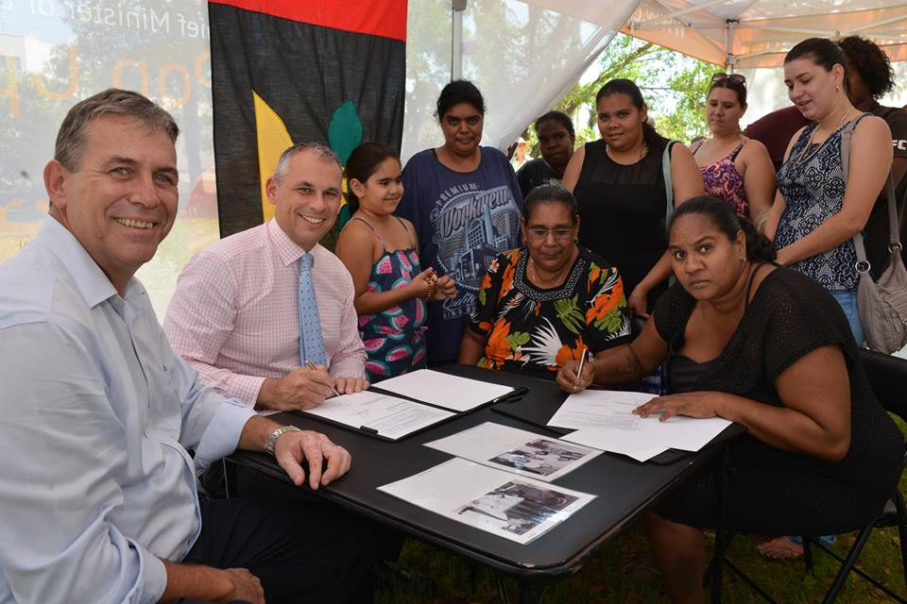
Three days later, on 21 September, 2015, Jane Bardon of the ABC reported that the Larrakia traditional owners were divided by the memorandum of understanding between the NT Government and the Gwalwa Daraniki Association. Bardon (2015) reported: “Ms Secretary said the plan would allow the Association to establish a commercial corporation to help it develop areas of the land between the Darwin suburbs of Ludmilla and Nightcliff for retail, industrial and residential use.”
Bardon quoted a Larrakia relative of the Secretary family, “Danggalaba Kulumbirigin man” Tibby Quall. Mr Quall said: “[The Secretary family] does not have exclusive rights to the land because it was granted for the collective use of all Larrakia people. [Mr Giles] hasn't consulted us, and the Secretarys and Gwalwa Daraniki haven't consulted us. The whole land is our land too, [belonging] to all our families, and anything that takes place on the land we should be involved or consulted too about it. We own this land and we should have a say in this land and we're very upset about that.”
The ABC report continued:
Lawyers for the Larrakia Nation Aboriginal Corporation are trying to block development with an order from the Northern Territory Heritage Council. The council last week rejected the Nation's application, but their lawyers, the Environmental Defenders Office (EDO), plan to appeal to the NT Civil and Administrative Tribunal. “It's premature of the Government to go ahead with this kind of memorandum of understanding prior to the outcome of this heritage process,” the EDO's Northern Territory principal lawyer David Morris said.
Mr Morris is also arguing the Special Purpose Lease land is collectively owned by more of Darwin's Larrakia people than just the few families who live on it.

Bardon (2015) claimed that Planning Minister Dave Tollner was not worried about the land ownership dispute. According to the ABC report, Tollner said, “We've said that we'd like to have some government officials involved in the record-keeping and making sure the financials are looked after.”

Bardon (2015) concluded: “The Secretary family has already made a deal with developers Ernie Chin and Jape so that retail premises can be built near the McDonalds on Totem Road. They said they were also being paid rent by Halikos to allow the developer to store piles of earth and rubble on the Special Purpose Lease [sic]. They said they had not yet engaged developers for other sites.”

Tollner and the Jape and Chin development proposals
At a public meeting at Fitzer Drive, Ludmilla, on 2 October 2012 to discuss applications by Jape's Citiland to develop 35 hectares of bushland on Lot 5182, Tollner unashamedly boasted of his “real soft spot for the Gwalwa Daraniki”. Standing alongside Gwalwa Daraniki Association lawyer, Michael Chin, with developer Ernie Chin and son in the audience, Tollner defended the GDA leaseholders despite the unruly disruption of the meeting by Helen Secretary, Mark Hopkins and Albert Treves from the Kulaluk community. The verbal threats and physical intimidation by the GDA members were recorded on video and uploaded to Youtube https://www.youtube.com/watch?v=JhvZIs9TdQw . Some of the transcript is reproduced below:

David Percival (MC): “We all feel we have been let down, that this was done without us knowing.”
Helen Secretary (interjecting aggressively): “Nothing to do with you. It's GDA's land, nothing to do with you. You've got your own property, you fucking look after your own property mate.”
Margaret Clinch: “It's Darwin people's land.”
Helen Secretary: “This was Larrakia land before you came here mate. I don't give a fuck! You mob kicking up a stink about land that's got nothing to do with you. Go back to where you come from!”
David Tollner: “Hang on, we've got to get something clear – this land can't stay like this. It's in a lot of ways a health risk. You can see there's weeds and stuff, it's been a dumping ground for years. Just staying the way it is is not [an option]. This lady over here, Helen Secretary, advises the Aboriginal Areas Protection Authority on what is sacred and what's not. She's also a member of the Tommy Lyons Group identified in the Justice Gray claim on Kenbi ... They're trying to derive an income and economic benefit from the land. Clearly there will be some people who don't want this land touched at all. And that, unfortunately, I don't think will happen. The fact is, there will be some sort of development occurring here. The only question we are dealing with here at the moment is what type of development it's going to be.”
Tollner [continuing]:“I don't have a particular view on it one way or the other. Mind you, I have to say I do have a real soft spot for the Gwalwa Daraniki Association who have been trying for years to derive some income from their land, so in that regard I want to see them develop something where they can earn an income and where they can find employment for their children and like.
“But the type of development that happens here I think really is primarily the responsibility of the developer and secondly, of the local community and I'd like to see as many people as possible have input into the process.
“I understand there are people here who don't want to see anything happen here and they want to see this continued conflict. That's not my desire ... I want to see people sitting down and in a responsible manner seeing how we can meet the interests of the GDA and also the winder community and actually get something here that will benefit the entirety of the Northern Territory area.”
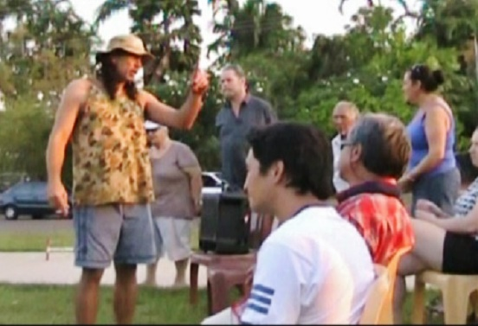
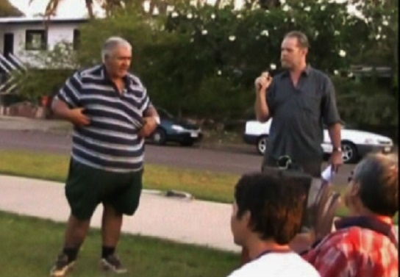

Above: Mark Hopkins and Albert Treves from the Kulaluk community interrupt the Fitzer Drive meeting.
Questioner to David Tollner: “Do we need any more sheds and warehouses?”
David Tollner: “We do need more sheds and we do need more development because Darwin is growing ... Winnellie is almost full up and there are businesses looking for a place to establish, and there is a very real shortage of places...”
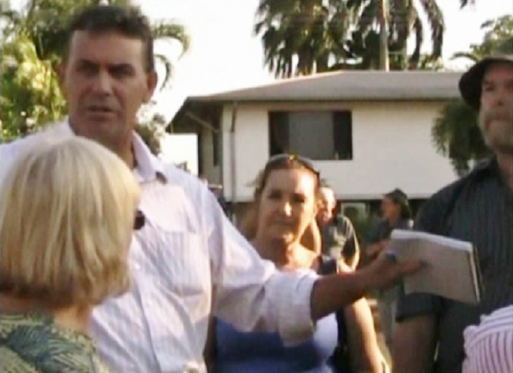

Top: Dave Tollner at the Fitzer Drive community meeting on 2 October 2012. https://www.youtube.com/watch?v=JhvZIs9TdQw

Tollner had previously revealed his attitude to proposals to develop the Kulaluk lease in answer to questions from Natasha Fyles, the MLA for Nightcliff.
The parliamentary committee transcript reads:
Ms FYLES: Thank you, minister. Going back to Kulaluk, what is the redevelopment proposal for the Kulaluk site?
Mr TOLLNER: At this stage there is no redevelopment proposal.
Ms FYLES: We have had advertising for rezoning in the area...
Mr TOLLNER: Sorry, I thought you were talking Kulaluk. You are talking about behind McDonald’s.
Ms FYLES: Sorry, minister, yes. It is a part of the broader conservation …
Mr TOLLNER: You are talking about Gwalwa Daraniki, the overriding body.
Ms FYLES: Thank you, minister.
Mr TOLLNER: There are two proposals. The Jape Group is proposing a development behind McDonald’s, and a company called Dragon Lady, I think it is – is it Dragon Lady? I think Dragon Lady is the name of the company.
Ms FYLES: Glad you clarified that. Minister, will you hold a community consultation meeting in relation to this development?
Mr TOLLNER: Let me tell you, community consultation meetings have been going on for years ...
Ms FYLES: I have seen some videos on YouTube.
Mr TOLLNER: I have seen a couple of videos myself. I have attended a number of them and this things is being debated uphill and down dale.
Ms FYLES: Minister, it is a pretty significant development in the heart of our city. What weight will be given to objections from the Defence Force, particularly the RAAF, and Darwin International Airport?
Mr TOLLNER: We always give a lot of weight to the Defence Force and the airport.
Ms FYLES: So you will take their objections?
Mr TOLLNER: I did not say that, I said we place a lot of weight on their views.
Ms FYLES: I guess this is a significant proposal and a significant change to the heart of our city which will have impact for generations to come, so it is important to understand what weight those objections will be given.
Mr TOLLNER: As I said, we take them very seriously. They are a legitimate organisation with a legitimate business operating in the Northern Territory. Obviously we listen to them when they have something to say.
Ms FYLES: Obviously we have the airport with significant commercial activity. It is also a military airport with …
Mr TOLLNER: That is right. What you are asking me, though, is whether we just dance to their tune all the time or whether we assess the things they say to us. So you want to know whether they can just dictate to us, is that what you are asking? Or we actually assess it? I have told you we take their point of view very seriously. What more do you want to know?
Ms FYLES: That airport has significant noise corridors. What role will that play in it?
Mr TOLLNER: Those noise lines outline exactly what is appropriate in a particular area. We are aware they do not want restaurants or areas where you could have a large, communal gathering of people. But the proposals that Jape are putting, and certainly the Western side of that development, is all light commercial, which fits neatly into those restrictions as they are. My understanding of the advice from Defence, is that they are opposed to restaurants, all of that sort of stuff, in that area because it is in a flight path. None of that is being proposed on that site.

The Kulaluk Aquaculture Projects
In 1997, excavation machinery began working deep inside the Kulaluk lease, in a tidal area draining into Ludmilla Creek, used by Darwin Aboriginal people for crabbing, fishing, and shellfish gathering. Five ponds varying from 9000 square metres to 1300 square metres, bordered by levee banks, were being gouged from the salt flats to create a three-hectare “prawn farm”. Within four years the $150,000 ponds lay as an abandoned mosquito-breeding haven. There was no evidence of restoration as stated under Schedule 10 of the Development Permit DP97/0077 (Maley & Davies 1997), “upon cessation of the use, the area used for ponds shall be rehabilitated to the requirements and satisfaction of the Secretary, Department of Lands, Planning and Environment.”

In 2005 came the announcement that the Commonwealth Government had signed a Shared Responsibility Agreement (SRA) with the Gwalwa Daraniki Association to provide “the foundations for a mud crab business that can employ young people and develop business skills amongst indigenous communities in Darwin harbour” See http://www.drbilldayanthropologist.com/kulaluk-crab-farm.php. A NT government publication, Common Ground, (July 2005, page 11), reported: “Following years of negotiations with NT Government’s Department of Business, Industry and Resources Development (DBIRD), a new Indigenous owned and operated mud crab aquaculture venture is to be set up by the Gwalwa Daraniki Association (GDA) in Darwin.”

Eric Tolzek (2006) in the NT News reported on 5 April:
People from the Kulaluk community have developed a mud crab farm business on their land at Coconut Grove. The farm using ponds from a failed prawn venture, will produce its first sale-sized crabs in three weeks. Workers from the community have been developing the venture since August. The farm worth $1.5 million is a joint venture between the NT Government and the Gwalwa Daraniki Association.

Sharon Hewitt (2006:12) writes: “The Gwalwa Daraniki Mud Crab farm is high on both the Territory and Australian Governments [sic] political agenda due to the government funding and support that has been injected into the project and its location in prime residential areas in the middle of Darwin.” She notes that the Mud Crab Farm was “established in November 2004 with the support of both the Commonwealth and NT government” (Hewitt 2006:13).

Combining all sources, the stakeholders in the two failed projects were as follows:
Gwalwa Daraniki Association Inc (Helen Secretary, Michelle Nelson); Gwalwa Daraniki Enterprises Pty Ltd; Tropical Aquaculture Australia (Dr Bob Rose and Phil Elsegood); Dept of Employment and Workplace Relations (DEWR) (Commonwealth Government); Member for Solomon (David Tollner MHR); NT Government (Dr Chris Burns); Charles Darwin University (Ian Ruscoe, Leyland Campbell); Curtin University (Jason Elsegood, Sharon Hewitt); NT Fisheries; Darwin Regional CDEP; NT Department of Agriculture; Forestry and Fisheries; Structured Training Employment Program (STEP); Shared Responsibility Agreement (SRA); NT Department of Business Industry and Resource Development (DBIRD); Office of Indigenous Policy Coordination (OIPC) (Project Officer. Rob Manley); Commonwealth Government (John Howard, Peter Costello, Dave Tollner); NT Planning Authority (John V Maley, Patricia Davies); SAFCOL; and North Australian Aquaculture Company.
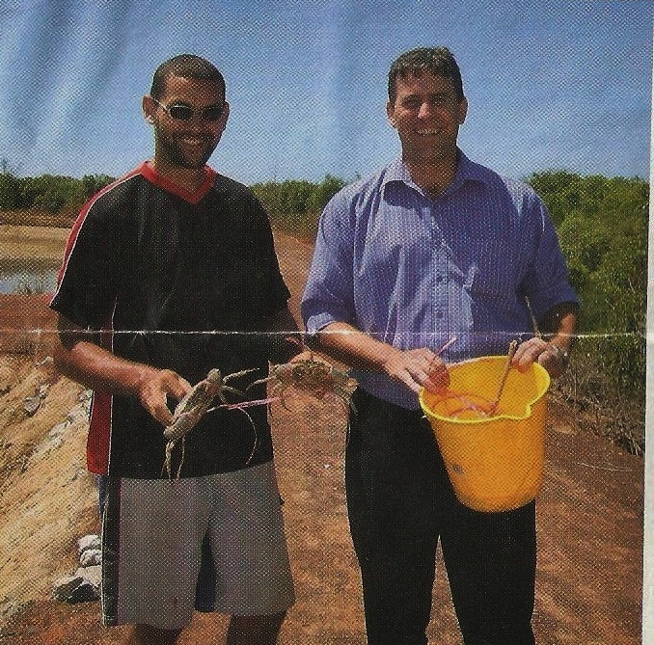

Above: Dave Tollner stands on the banks of the Gwalwa Daraniki Enterprises Pty Ltd crab farm on the Kulaluk Lease in 2007.

The ABC in Darwin reported on 28 March 2007 that “Federal Member for Solomon, David Tollner MP announced the Australian Government has given approval for funding of up to $433,180 under the Regional Partnership Programme for the development of stage two of the Kulaluk Mudcrab Farm at Nightcliff. Mr Tollner said the Australian Government funds will assist Gwalwa Daraniki Enterprises Pty Ltd to expand the pond area complete capital works and purchase materials.” (ASIC's database shows that Gwalwa Daraniki Enterprises Pty Ltd's business name was “Mudla Farms”, registered on 16 June 2005. The database shows that the business name Mudla Farms was cancelled on 28 October 2008).

As the NT member for the Federal seat of Solomon, in 2007, Dave Tollner published a glossy photograph of himself holding a bucket besides a member of the GDA holding a mud crab with the caption, “Creating jobs to help our community. Dave Tollner and the Howard government are working with local communities to support local ideas and create local jobs.” Hewitt (2006:13) cites a speech made by federal treasurer Peter Costello when he visited the crab farm in 2006.

No doubt with Dave Tollner by his side, Costello said:
It is great to be here at the Mudla Crab Farm, to try what were the most delicious crabs I have ever eaten in my life and to see a project like this which is a real commercial project, giving training, giving jobs, making a profit and providing for the local people an economic base and that is what I think indigenous affairs is going to be about in the future, real economic opportunity, real jobs, real investment and real business.

By 2009 the aquaculture ponds lay abandoned once more, with expensive infrastructure rotting in the tidal mud. Business records and financial statements lay scattered around a demountable office with generators covered by jungle vines and weeds. Power poles and pipelines leading to nowhere extended through the mangroves 800 metres to the arterial road of Dick Ward Drive. No inquiry has ever been held into the scandal of Dave Tollner's multi-million dollar “Crabgate”.

Dave Tollner and the Halikos Stockpile
In response to queries from Margaret Clinch of PLan, David Ritchie (2010), the then head of Department of Lands and Planning wrote:

The stockpile of fill located at Lot 5182 Dick ward Drive, Town of Darwin (Minmarama Estate) commenced in approximately November 2006. The placement of fill is understood to have originated through a private arrangement between the lessees (Gwalwa Daraniki) and a private construction company...

Clause 6.16 (Excavation and Fill) of the NT Planning Scheme requires the consent of the Development Consent Authority (DCA) for the stockpiling of fill and the Department has sought legal advice in relation to whether existing use rights apply to the stockpiling that occurred prior to February 2007. This advice has now confirmed that the stockpiling is not protected by existing use rights and the Department and DCA are actively seeking to have this use ceased and the site rehabilitated...

The DCA has recently issued a ‘Notice to Cease’ under the Planning Act for the stockpiling of fill and has requested that the owners provide a written response outlining a timetable for remediation.

According to the NT News (Langford 2010a, 2010b:7): “The rubble has come from development sites around Darwin through a deal brokered by estate agent Ernie Chin with the land’s leaseholder, the Gwalwa Daraniki Association.”

Ben Langford’s report (2010b:7) continues:

Mr [Ernie] Chin said developers Halikos had an agreement for depositing fill but did not think they would have to move it. I very much doubt it”, he said. “They put it there under license from the Aboriginal people who were told they could do it.”

According to a report by Alison Bevege, Halikos Group Managing Director Shane Dignan said that Halikos would be using the rubble. Bevege (2013:23) notes:

The DCA did not issue a Notice to Cease under the Planning Act until this year [2013]. When asked what enforcement action was taken the department said it had been “working with the landowner to facilitate removal of the fill from the property”. It is also suspending the enforcement action until the application process is finished.

In an attempt to close the gate after the horse had bolted, an Exception Development Permit Application appeared in the NT News on 19 April, 2013, page 40 (Second Advertisement) with closing date for submissions, Friday, 3rd May, 2013.

As a result, a year later on 15 May, 2014, Peter Chandler, the Minister for Lands, Planning and the Environment gave notice that:

(a) I have in pursuance of section 40(2)(d), refused to grant an Exceptional Development Permit for Lot 5182 (213) Dick Ward Drive, Town of Darwin;
(b) an Exceptional Development Permit has been refused for the purpose of an operational stockpile of fill;
(c) the land is within Zone CN (Conservation) of the NT Planning Scheme, and the development proposed would otherwise be prohibited;

Chandler (2014) stated that he believed “the integrity of the surrounding areas within Zone CN would be eroded during the period of any ongoing use for this purpose and as such the overall context and value of the zoning for the area in the longer term is likely to be detrimentally impacted.”

Minister Chandler continued: “...any decision to allow the introduction of an industrial use, adjacent to, and with access through a low density residential community [Minmarama], in an area so proximal to sensitive vegetation communities with significant physical constraints, should in my view only be taken in the broader policy context and having regard to the longer term intentions for the locality.”

Chandler (2014) noted, “The Reporting Body report includes 58 submissions all in opposition to the proposal indicating considerable community passion and identifying numerous and varied concerns...”

Significantly, in May, 2015, Minister for Lands and Planning, Dave Tollner (2015) confirmed that the stockpile was illegal. Tollner wrote to a Fong Lim constituent, Ann-Marie Grant (my emphasis):

My predecessor also took steps to ensure the appropriate use of Lot 5182 by refusing to consent to a recent application for the unlawful stockpile of fill located at the end of Fitzer Drive and required the stockpile to be removed. My Department is monitoring this situation to ensure compliance, with a 'fill removal and revegetation management plan' required to be developed.

The GDA has breached the conditions of its “Crown Lease in Perpetuity” in many ways and signed numerous secret deals with developers. An amended constitution signed off by lawyer Michael Chin in 2006 has severely limited membership of the association. Meanwhile, the Minister for Lands and Planning, David Tollner has demonstrated his alliance with the GDA in public utterances and by signing a MoU with the leaseholders in 2015. The Larrakia traditional owners of the land have presented a powerful defence for heritage listing of the entire lease; however, under the Heritage Act, the final decision rests with the Minister – a politician who has not been endorsed by his party for the forthcoming Northern Territory election in August 2016 and has demonstrated a contempt for his constituents.

This essay is intended to show that the Minister has a proven conflict of interest and therefore his decision to reject the heritage listing of the Kulaluk Lease Area should not stand. The appeal against the Minister's decision by the Environment Defender's Office and their lawyer, David Morris, representing the Larrakia Nation Aboriginal Corporation. began with a brief hearing in the Darwin Supreme Court on June 16, and has been adjourned to August 3, 2016 (Davidson 2016b).

References:
Bardon, J 2015 “Larrakia people divided over development plan for Indigenous land in Darwin”, ABC report Monday 21 September 2015.
Bevege, Alison 2013 “Trouble with the rubble”, NT News, 17 April 2013, p. 23.
Chandler, P G 2014 Determination of Application for Exceptional Development Permit PA 2013/01`70 – Operational Stockpile of Fill on Lot 5182 (213) Dickward Drive, Town Of Darwin, 15 May 2014.
Day, Bill 2016 http://www.drbilldayanthropologist.com/kulaluk-crab-farm.php
Davidson, Helen 2016a “Indigenous heritage and development: the fight over Darwin's Kulaluk lease”, The guardian online, 2 May, 2016. https://www.theguardian.com/australia-news/2016/may/02/indigenous-heritage-and-development-the-fight-over-darwins-kulaluk-lease
Davidson, Helen 2016b “Planning minister refusal to give Aboriginal land heritage listing to be challenged in court”. The Guardian online, 2 June 2016 [ https://www.theguardian.com/australia-news/2016/jun/02/planning-minister-to-face-court-over-refusal-to-heritage-list-aboriginal-land ].
Dunlop, Craig 2016a “Dismay over burial site fate”, Darwin Sun, Tuesday 23 February 2016, page 3.
Dunlop, Craig 2016b “Heritage decision looms for Kulaluk”, NT News, 6 March 2016, page10.
Giles, A & D Tollner 2015 “Indigenous communities free to build a better future” (media release), Darwin, 18 September 2015.
Hewitt, Sharon 2006 Our Vision to Economic Independence and Employment and Educational Opportunities for our Community: an evaluation of Gwalwa Daraniki Enterprises Mud Crab Farm Employment Program, Bentley, WA: Curtin University.
Langford, Ben 2010a “DCA orders molehill made of dirt mountain”, NT News, 15 April, p. 3.
Langford, Ben 2010b “No one claiming big heap of rubble”, NT News, 21 April 2010, p.7.
Maley, J & P Davies 1997 Kulaluk Prawn Farm Project (Aquaculture) Development Permit DP97/0077 Lot 5182 Town of Darwin. Northern Territory Planning Authority, 12 Feb., 1997.
NT Government 2005 “New Darwin Crab Farm”, Common Ground, July, page 11.
Secretary, Helen 2016 “We can decide”, NT News, letter to Editor, Monday 21 March 2016, page 12.
Tollner, David 2015 Letter from David Tollner, Minister for Lands and Planning, to Ann-Marie Grant, 7 May, 2015.
Tollner, David 2016 Information notice under the Heritage Act, 29 April 2016.
Tolzek, Eric 2006 “Aboriginal crab farm claws at own future”, NT News, 5 April 2006, page 8.
Walsh, Christopher 20-16 “Heritage rejection en route to court”, NT News, Monday 6 June 2016, p. 4.
Wood, David 2014 “Larrakia: hands off lease site”, NT News, Friday 11 July 2014, page 10.
Youtube “Community meeting at Fitzer Drive” https://www.youtube.com/watch?v=JhvZIs9TdQw

